Excel Assignment - 6

1. What are the various elements of the Excel interface? Describe how they're used.

Quick Access Toolbar,

This toolbar is located in the upper left corner of the screen. Its objective is to show the most frequently used Excel commands. We can customize this toolbar based on our preferred commands.

Ribbon

**Ribbon/Toolbar** is a set of commands organized into three sections. Tabs,groups and commands

Name Box

It shows the location of the active cell, row, or column.

Formula Quick Menu

It allows you to edit the content of cell or formular bar

Formula Bar

Formula bar permits us to observe, insert or edit the information/formula entered in the active cell.

Status Bar

The status bar is present at the bottom of the window that displays critical information. It also indicates whether something is incorrect or whether the document is ready to be printed or delivered.

Worksheet View Options

View buttons are a set of three buttons arranged at the left of the Zoom control, close the screen's right-bottom corner. We can see three different kinds of sheet views in Excel using this method.

Zoom Slider Control

The zoom control is present at the **lower-right** side of the window. It enables us to **ZOOM-IN** or **ZOOM-OUT** a specific area of the spreadsheet.

and the Zoom Percentage Indicator.

1. Write down the various applications of Excel in the industry.

* Data Entry and Storage
* Performing Calculations
* Data Analysis and Interpretation
* Reporting and Visualizations
* Accounting and Budgeting
* Collection and Verification of Business Data
* Calendars and Schedules
* Administrative and Managerial Duties
* Forecasting
* Automating Repetitive Tasks

|  |  |
| --- | --- |
|  |  |
|  |  |
|  |  |
|  |  |
|  |  |

1. On the ribbon, make a new tab. Add some different groups, insert commands in the groups and name them according to their commands added. Copy and paste the screenshot of the steps you followed.

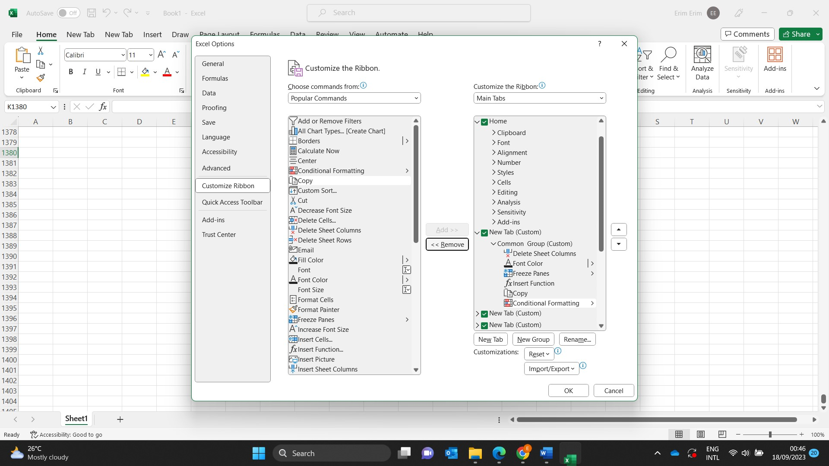

1. Make a list of different shortcut keys that are only connected to formatting with their functions.

Keyboard shortcuts for formatting cells

|  |  |
| --- | --- |
| **To do this** | **Press** |
| Italicize text or remove italic formatting. | **Ctrl+I or Ctrl+3** |
| Bold text or remove bold formatting. | Ctrl+B or Ctrl+2 |
| Underline text or remove underline. | Ctrl+U or Ctrl+4 |
| Apply or remove strikethrough formatting. | Ctrl+5 |

1. What distinguishes Excel from other analytical tools?

* It builds the [charts](http://www.excel-easy.com/data-analysis/charts.html)
* It makes use of conditional formatting.
* It helps to organize the data.
* It will identify trends.
* It provides online access.

1. Create a table and add a custom header and footer to your table.

